May 22, 2012
Are you a legend in your own mind?
(aka... I'm-an-Ibra-Her-Ovich)
So, a couple of weeks ago I was playing in a casual league and a man came up to me and told me that a goal I'd scored recently reminded him of Zlatan Ibrahimovic.
It was about a 35 yarder, he said, still rising as it hit the net. (woo hoo!!)
No, I didn't really remember, and I reminded him that "I get hit in the head a lot."
(Dan Marino's funny comment from Ace Ventura always pops into my head whenever people tell me I'm crazy to head corner kicks.)
Since Abby Wambach is my hero, I was a bit taken aback to be compared to a male player whose name I barely knew.
So, of course, I had to know more about my alter ego.
I Googled Ibrahimovic and ... as it turns out, the guy was at least partly right.
1. We both play striker
2. We both have ponytails (see mine in the photo at the top of the page?)

3. We're both big players (tall/strong) and like to use our size to keep the ball.
Also we get called for dangerous play/high kicks a lot.
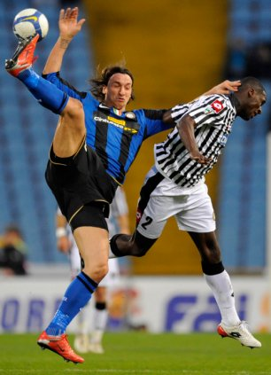

4. We both think we're pretty funny and charming. ;)
Once, Ibrahimovich explained how he beat a defender to score a goal: “First I went left, he did too. Then I went right, and he did too. Then I went left again, and he went to buy a hot dog.” LOL!!
5. We're both frequently misunderstood.
After Zlatan signed with Ajax in 2001, Co Adriaanse reportedly said,
"He really has good technique. You don't see that very often with tall players. Probably because of the bigger distance between the brains and the feet."
Hey, wise guy... better not turn your back when you're in the technical box. :)
6. We always try to find a way to score.
Then, I went on YouTube and pulled up a Zlatan's "30 best goals" compilation created by a fan and realized... Yeah... that could be me (in my dreams!)
Not exactly the same, of course, and not playing at the same level, but still... the number of ways he can manipulate the ball is mind boggling.
It's what I really want to be - a Master of the Ball.
One of my favorite moments in the past couple of years was during a casual 4v4 game, when I overheard 2 women say to each other after I'd scored on their team, "I don't even understand how she got that into the goal."
(Thank you Hubert Vogelsinger, creator of "Soccerobics", the VHS tape from which I learned to dribble the ball like a basketball player with the soles of my feet. I can also do a really good "butt trap" to control a high ball, but I have not had the chance to use that in a game yet.)
I admire the way that Zlatan carries defenders along with him on the way to goal, the sheer persistence in not giving up on a run and bearing down even more when the defenders are facing their own goal.
The best way I can describe Zlatan is Johan Cruyff on Red Bull. I am reminded of hearing an opposing defender whine, "Can't you just STOP?" Uh, no. Not really. If I stop, I will die. (JK)
I should be watching Zlatan play as often as possible because he's my "type". Watching him makes me realize that I can be a dribbler - I just have to use my own style and physicality to beat the defender. He rarely comes to a complete stop, he zigzags through, which gives him momentum. You can see the defenders try to foul him, but they're not fully committed to either the tackle or the foul, and he just goes right on through with his size. (See Goal #2 in YouTube video below.)
On the other hand... my research uncovered some things about Zlatan that I try to avoid:
retaliating when fouled, being rude to the press, criticizing coaches' decisions, and a tendency to be cocky (though I can see it might be a little hard to be humble when you can score on a leaping backheel in a crowded goalmouth melee…
https://www.youtube.com/watch?v=LD7J5jq15T0

And now... go find YOUR alter ego... the one whose play makes you dream of what you can do.
You might have to look pretty hard, because it might be a ponytailed Swedish guy playing in Italy.

